SIMATS ENGINEERING
Saveetha Institute of Medical and Technical Sciences
DEPARTMENT OF COMPUTER SCIENCE AND ENGINEERING
VISIONGUARD:
MULTI-MODULE VISION SYSTEM DESIGN
FOR CAMPUS ACCESS AND SURVEILLANCE
A COMPUTER VISION ASSIGNMENT REPORT
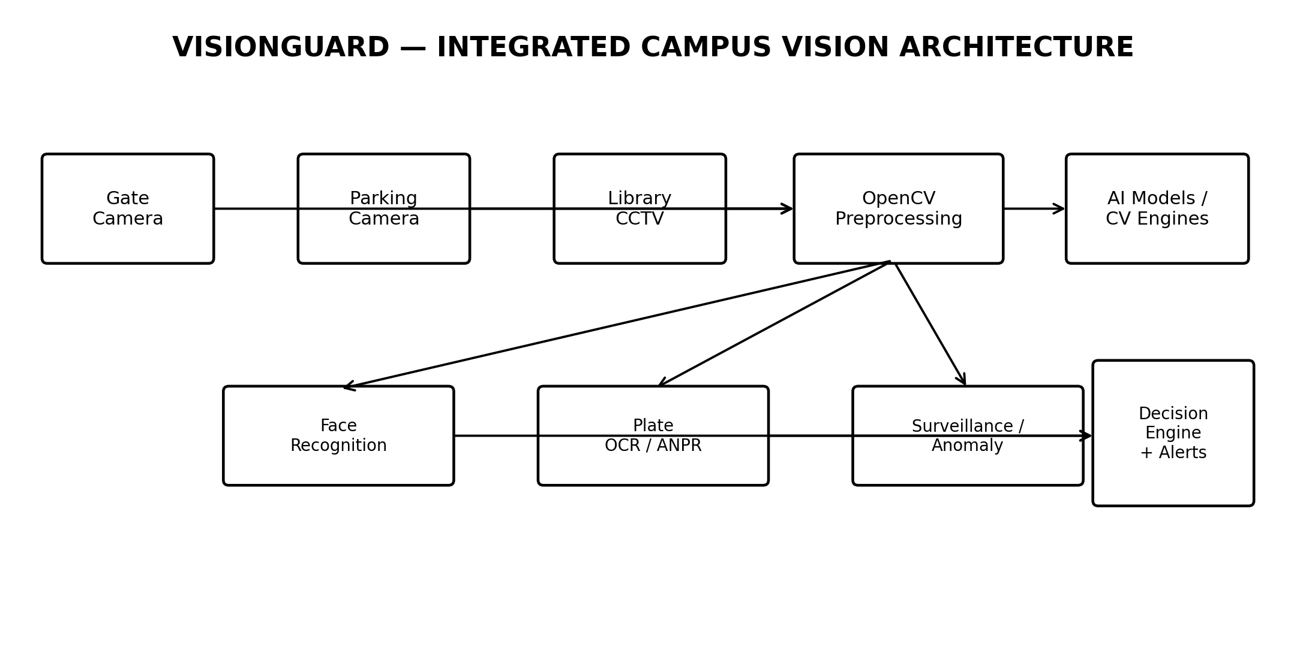
Course: ITA05 – Computer Vision
Submitted by
SHAIK ABDUL AVEZ (192472260)
K ADITYA(192421015)
L K LOKESH (192421009)
Under the Supervision of
Dr. V R VIMAL
Chennai – 602105
2026

DECLARATION
I, Shaik Abdul Avez (192472260) K Aditya (192421015) and L k Lokesh (192421009), Department of Computer Science and Engineering, SIMATS Engineering, hereby declare that the assignment report titled “VisionGuard: Multi-Module Vision System Design for Campus Access and Surveillance” is prepared for the course ITA05 – Computer Vision. The work presented in this report is based on the supplied assignment problem statement and represents my academic analysis, system design, algorithm selection and proposed implementation approach.
I further declare that the report has been prepared for academic evaluation and that sources used for technical background have been acknowledged. Any implementation results reported in the final project should be replaced or supplemented with experimentally measured results obtained from the actual datasets and test environment.
Place: Chennai
Date: __________ / 2026
Signature of Student: ______________________________
Shaik Abdul Avez (192472260)
K Aditya (192421015)
L k Lokesh (192421009)
BONAFIDE CERTIFICATE
Certified that this assignment report titled “VisionGuard: Multi-Module Vision System Design for Campus Access and Surveillance” is the bonafide academic work of Shaik Abdul Avez (192472260),
K Aditya (192421015), L k Lokesh (192421009), carried out for ITA05 – Computer Vision under the guidance of the faculty member mentioned below.
Guide / Faculty Name : Dr. V R VIMAL
Designation: Professor
Department of Computer Science and Engineering
SIMATS Engineering
Internal Examiner: ____________________ External Examiner: ____________________

ABSTRACT
VisionGuard is a proposed integrated computer-vision system designed for three campus security and monitoring scenarios: authorized person recognition at the main access gate, automatic vehicle number-plate recognition at the parking entrance, and unusual-activity detection from a library surveillance stream. The problem requires reliable operation despite illumination variation, camera noise, viewpoint changes, motion blur and other limitations typical of campus CCTV hardware.
The proposed design follows a layered vision pipeline in which image enhancement, filtering, segmentation, region-of-interest extraction and feature preparation precede module-specific recognition. Traditional methods such as Haar cascades, LBPH, contour/template matching and background subtraction are evaluated against deep-learning alternatives including CNN-based face embeddings, learned plate detection with OCR, YOLO-style object detection and temporal anomaly analysis.
The recommended architecture is hybrid. OpenCV remains the central image/video processing layer because it provides efficient preprocessing, geometric transformation, feature operations, video handling and model inference support. Deep learning is selected for recognition and detection tasks where robustness to pose, lighting and appearance variation is critical. The report also considers accuracy, adaptability, computational demand, training data, deployment constraints and privacy of biometric and vehicle information.

ACKNOWLEDGMENT
I express my sincere gratitude to the faculty members and the Department of Computer Science and Engineering, SIMATS Engineering, for providing the academic environment and guidance required to complete this Computer Vision assignment. I also acknowledge the assignment brief, which clearly defined the VisionGuard problem, course outcomes, assessment criteria and deliverables.
I am grateful to my faculty guide for guidance in understanding image enhancement, segmentation, feature extraction, object detection and the comparative evaluation of traditional and deep-learning approaches. I also thank my classmates, friends and family for their encouragement and support during the preparation of this report.

TABLE OF CONTENT
CONTENTS
1 INTRODUCTION ................................................................ 5–6
1.1 Background and Motivation ................................................. 5
1.2 Objectives and Scope ........................................................ 5
1.3 VisionGuard Functional Requirements .................................... 6
1.4 Methodology Overview ....................................................... 6
2 PROBLEM IDENTIFICATION & ANALYSIS .............................. 7–8
2.1 Campus Vision Challenges .................................................. 7
2.2 Stakeholders and Constraints .............................................. 7
2.3 Risk and Failure-Mode Analysis ............................................ 8
3 SOLUTION DESIGN & IMPLEMENTATION ................................ 9–11
3.1 System Architecture .......................................................... 9
3.2 Preprocessing and Feature Engineering ................................. 9
3.3 Face Recognition ............................................................... 10
3.4 ANPR and OCR ................................................................. 10
3.5 Library Surveillance .......................................................... 11
4 COMPARATIVE EVALUATION & RESULTS ............................... 12–13
4.1 Traditional vs Deep Learning ............................................... 12
4.2 Evaluation Metrics and Testing ............................................ 12
4.3 Expected Results and Error Analysis .................................... 13
5 PRIVACY, ETHICS, SDG & RECOMMENDATIONS ...................... 14
6 REFLECTION & CONCLUSION ............................................... 15
7 REFERENCES .................................................................... 15

CHAPTER 1

INTRODUCTION

1.1 Background and Motivation
Modern campus security increasingly depends on cameras positioned at access gates, parking areas and common spaces. A camera network, however, becomes useful only when the captured visual information can be processed into reliable events. VisionGuard addresses this requirement by combining three related computer-vision tasks into one pipeline: identity recognition, vehicle identification and surveillance analysis.
The supplied assignment describes a campus environment in which registered students/staff must be recognized at the gate, vehicle plates must be read at the parking entrance, and unusual activity must be flagged in a library feed. It also emphasizes robustness to lighting, camera angle and image noise. fileciteturn0file0L51-L56

1.2 Objectives
- Design an integrated OpenCV-based vision system for three campus scenarios.
- Apply image enhancement, filtering, segmentation and feature extraction before recognition.
- Compare traditional methods with deep-learning approaches on accuracy, adaptability and cost.
- Select the most suitable method for each module and justify the selection.
- Define a realistic implementation, testing and deployment strategy.
- Address privacy and ethical requirements for biometric and vehicle data.

1.3 Scope
The scope covers image/video acquisition, preprocessing, face recognition, number-plate localization and OCR, surveillance motion/object analysis, event decisions, evaluation metrics and secure deployment. The report is a system-design and implementation plan; measured accuracy values should be obtained from the actual datasets used during implementation.

1.4 VISIONGUARD FUNCTIONAL REQUIREMENTS
- Gate access: detect a face, normalize it, identify the enrolled person and produce an access decision.
- Parking entrance: detect a vehicle/plate, rectify the plate, enhance characters and recognize plate text.
- Library surveillance: detect people/objects, track motion and identify activity that violates configured rules or produces an abnormal temporal pattern.
- System monitoring: record confidence, timestamp, camera/event ID and decision outcome where permitted.
- Human escalation: route low-confidence recognition and uncertain anomaly events to manual review.

1.5 Non-Functional Requirements
- Reliability: the pipeline should remain stable under camera noise and changing illumination.
- Low latency: inference should be fast enough for the intended gate, parking and CCTV workflows.
- Maintainability: modules should be independently replaceable and testable.
- Security: biometric and plate data must be protected using access control and secure storage.
- Scalability: the design should permit additional cameras, models and analytics services.
- Auditability: important decisions should be traceable through confidence values and event logs.

1.6 Methodology Overview
The methodology begins with data acquisition and annotation, followed by preprocessing and segmentation. Each module then applies a suitable detector and recognition stage. Training/validation is required for learned models, while traditional baselines provide a reference for comparison. Finally, the system is evaluated using module-specific metrics and tested under controlled variations such as low illumination, blur and viewpoint changes.
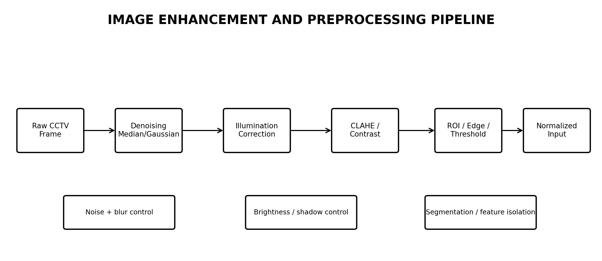

CHAPTER 2

PROBLEM IDENTIFICATION & ANALYSIS

2.1 Campus Vision Challenges
The main technical challenge is variability. A face may be captured with a different pose or illumination from its enrollment image. A vehicle plate may be tilted, reflective or partially blurred. Library surveillance includes continuous background movement, shadows and changing scene conditions. A fixed threshold or handcrafted descriptor can therefore work well in one scene and fail in another.

2.2 Stakeholders
- Campus security personnel: require dependable access decisions and alerts.
- Students and staff: expect legitimate access without unnecessary false rejection.
- Parking/security administrators: require reliable plate records and event timestamps.
- Library management: requires useful alerts without excessive false alarms.
- System administrators: maintain cameras, models, databases and logs.
- Data-protection stakeholders: ensure responsible handling of biometric and vehicle information.

2.3 Major Constraints
- Camera resolution and frame rate can limit recognition quality.
- Edge hardware may not support large deep-learning models at high FPS.
- Training data must represent actual campus conditions.
- Privacy requirements limit how long biometric and plate information should be retained.
- False positives can reduce trust; false negatives can create security gaps.

2.4 FAILURE-MODE AND RISK ANALYSIS
Failure Mode | Cause | Impact | Mitigation
Face false rejection | Pose / glare / blur | Access delay | Quality check, alignment, multi-frame voting
Face false acceptance | Look-alike / weak threshold | Security risk | Validated threshold, liveness/quality checks, manual escalation
Plate OCR error | Perspective / glare | Incorrect record | Rectification, preprocessing, repeated-frame OCR
Motion false alarm | Shadow / illumination | Alert fatigue | ROI masks, temporal filtering, object-aware rules
Model drift | Camera or environment change | Performance decline | Periodic validation and monitoring
Data exposure | Weak access controls | Privacy breach | Encryption, RBAC, retention policy, audit logs

2.5 Problem Analysis Summary
The central design problem is to achieve reliable automated decisions without treating a single algorithm as universally best. Traditional methods provide speed and interpretability, while deep learning provides stronger adaptability when representative data are available. The system therefore needs module-specific model selection rather than a one-size-fits-all solution.

2.6 Dataset Strategy
- Face dataset: multiple images per enrolled identity across lighting and viewpoints.
- Plate dataset: vehicle/plate images covering distance, angle, blur and illumination conditions.
- Surveillance dataset: labelled normal activity and representative unusual events.
- Split data into training, validation and independent test sets where training is required.

CHAPTER 3

SOLUTION DESIGN & IMPLEMENTATION

3.1 End-to-End Architecture

The architecture uses cameras as input sources and OpenCV as the common image-processing layer. Module-specific engines perform face recognition, plate detection/OCR and surveillance analysis. A decision engine combines model confidence with validation rules and produces access decisions or alerts. This separation makes it possible to replace a model without redesigning the entire system.

3.2 Engineering Design Principles
- Modularity: separate acquisition, preprocessing, recognition, decision and logging.
- Configuration-driven thresholds: keep camera and model parameters outside core logic.
- Confidence-aware decisions: preserve confidence values instead of returning only binary results.
- Multi-frame reasoning: combine observations when the scene is continuous.
- Fail-safe behavior: uncertain results should escalate rather than silently grant access.

3.3 FACE RECOGNITION MODULE
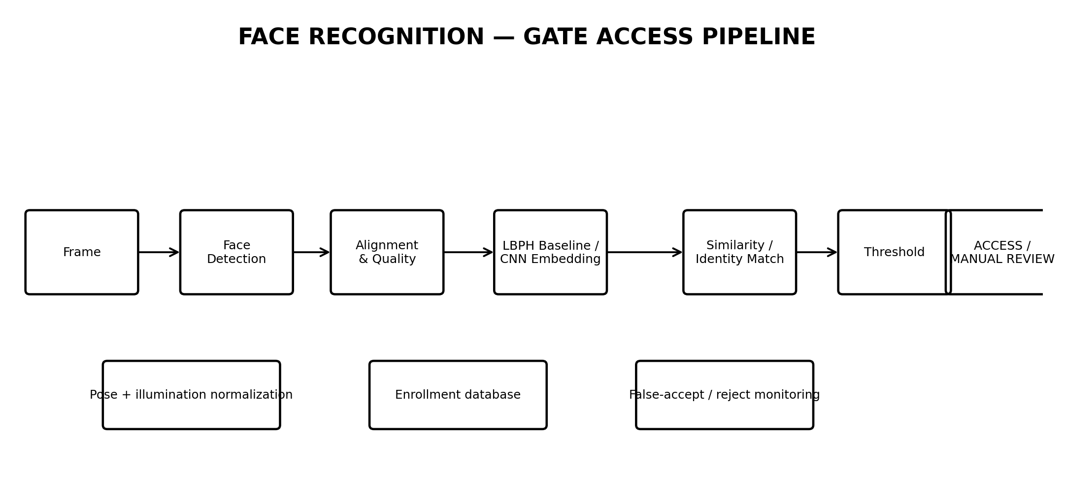
Traditional baseline: Haar cascade detection followed by grayscale normalization and LBPH recognition. This is computationally light and interpretable, but its robustness decreases under pose and appearance variation. Deep alternative: a learned detector plus CNN face embedding, followed by similarity matching against enrolled identities. The recommended implementation uses the deep-learning method for the primary recognizer and keeps the classical pipeline as a baseline.

3.4 NUMBER PLATE RECOGNITION MODULE
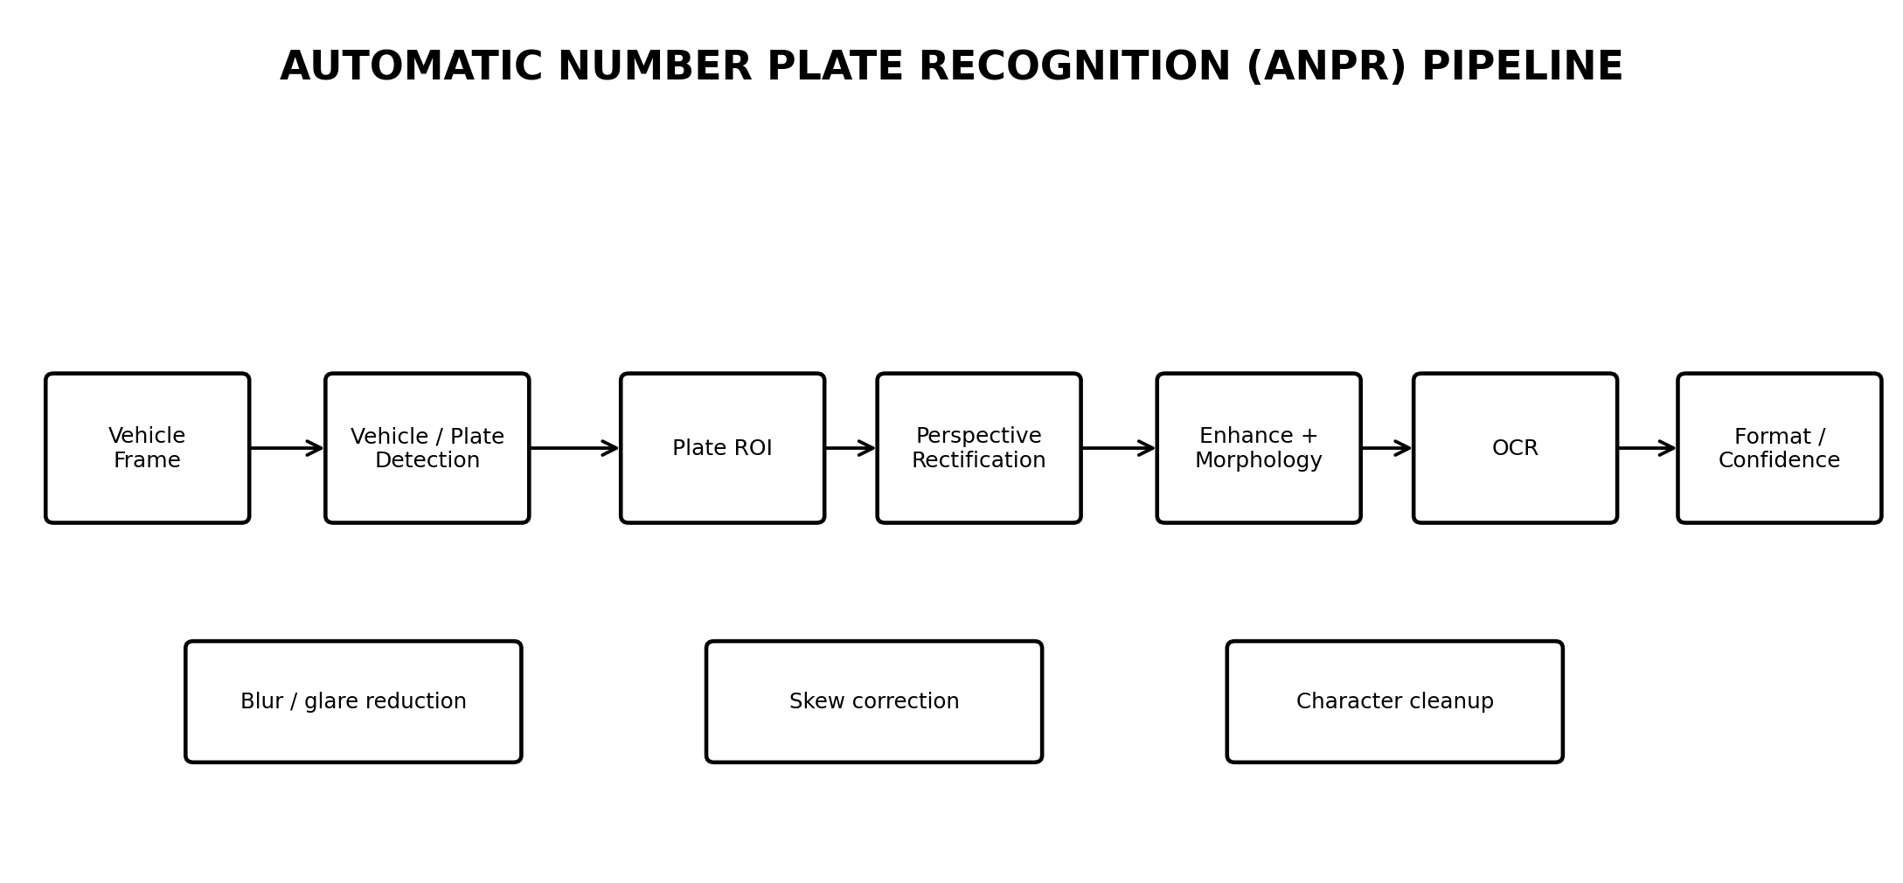
Traditional ANPR can use contours, plate geometry, thresholding and template-based character matching. The proposed advanced approach uses learned plate localization followed by perspective correction, enhancement and OCR. Classical morphology and format validation remain useful because they reduce noise and reject implausible outputs.

3.5 LIBRARY SURVEILLANCE MODULE
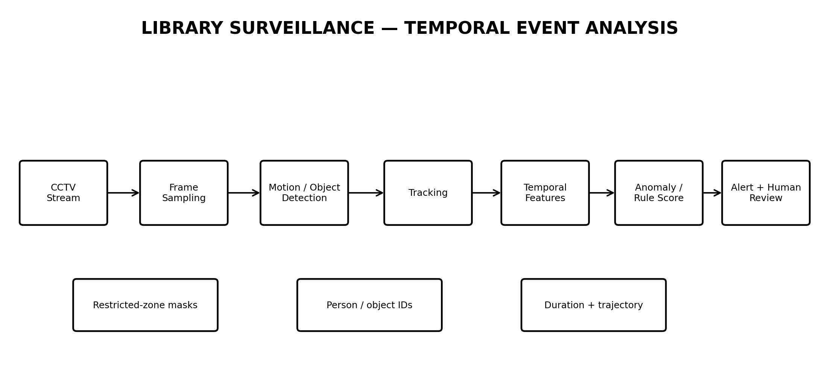
The surveillance module treats activity as a temporal problem. Traditional background subtraction can provide a fast foreground mask, while contours and motion features can support simple zone-based rules. A deep detector can identify people and objects more robustly, while tracking maintains identities across frames. The recommended hybrid pipeline combines learned detection with OpenCV-based video processing and temporal decision rules.

3.6 Example Event Logic
IF person enters restricted ROI AND duration > configured threshold
THEN increase event score.
IF multiple consecutive frames confirm the event AND confidence is high
THEN create an alert for human review.
ELSE continue monitoring and avoid a single-frame alarm.

3.7 Integration
All three modules should return a common event structure containing camera identifier, timestamp, event type, confidence and decision status. This enables a shared dashboard, audit trail and performance-monitoring layer.

CHAPTER 4

COMPARATIVE EVALUATION & RESULTS
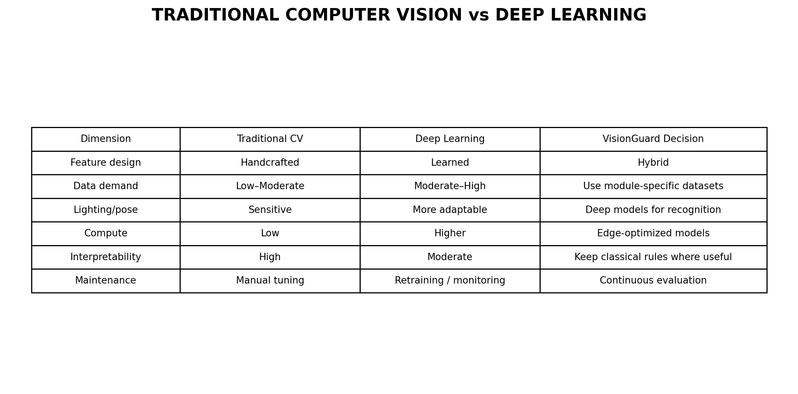

4.1 Module-Wise Selection
- Face recognition → CNN embedding recognition with OpenCV preprocessing; Haar/LBPH retained as baseline.
- Plate reading → deep detector + OCR with OpenCV rectification and morphology.
- Surveillance → learned object detection + tracking + temporal rules; background subtraction as a lightweight baseline.

4.2 Evaluation Metrics
The assignment rubric specifically expects accuracy, sample detections, visualizations and comparative analysis for all three modules. fileciteturn0file0L100-L105

4.3 TESTING AND EXPECTED RESULTS
No experimental accuracy values are invented in this report because the supplied assignment brief defines the problem and deliverables but does not provide a measured dataset or test results. The final implementation should populate the following result categories after testing.
Module | Baseline | Advanced Method | Report
Face | Haar + LBPH | CNN embeddings | Accuracy, FAR, FRR, latency
Plate | Contours + templates | Detector + OCR | Character/plate accuracy, confidence
Surveillance | Background subtraction | Detector + tracking | Precision, recall, false alarms, latency

4.4 Comparative Interpretation
The expected engineering outcome is not simply that deep learning is ‘better’. Its benefit must be measured against computation, training data and deployment constraints. A compact deep model running on edge hardware may be preferable to a larger model that produces higher offline accuracy but cannot meet real-time requirements. Similarly, a classical preprocessing step may improve the performance and stability of a deep model without replacing it.

4.5 Implementation Pseudocode
INITIALIZE cameras, OpenCV preprocessing and module models
FOR each synchronized/available frame:
preprocess frame → denoise → illumination/contrast correction
gate: detect face → align → recognize → threshold → access/manual review
parking: detect vehicle/plate → rectify → enhance → OCR → validate
library: detect/track → compute temporal features → score → alert/review
log permitted metadata and display annotated results
END

CHAPTER 5

PRIVACY, ETHICS, SDG MAPPING & RECOMMENDATIONS
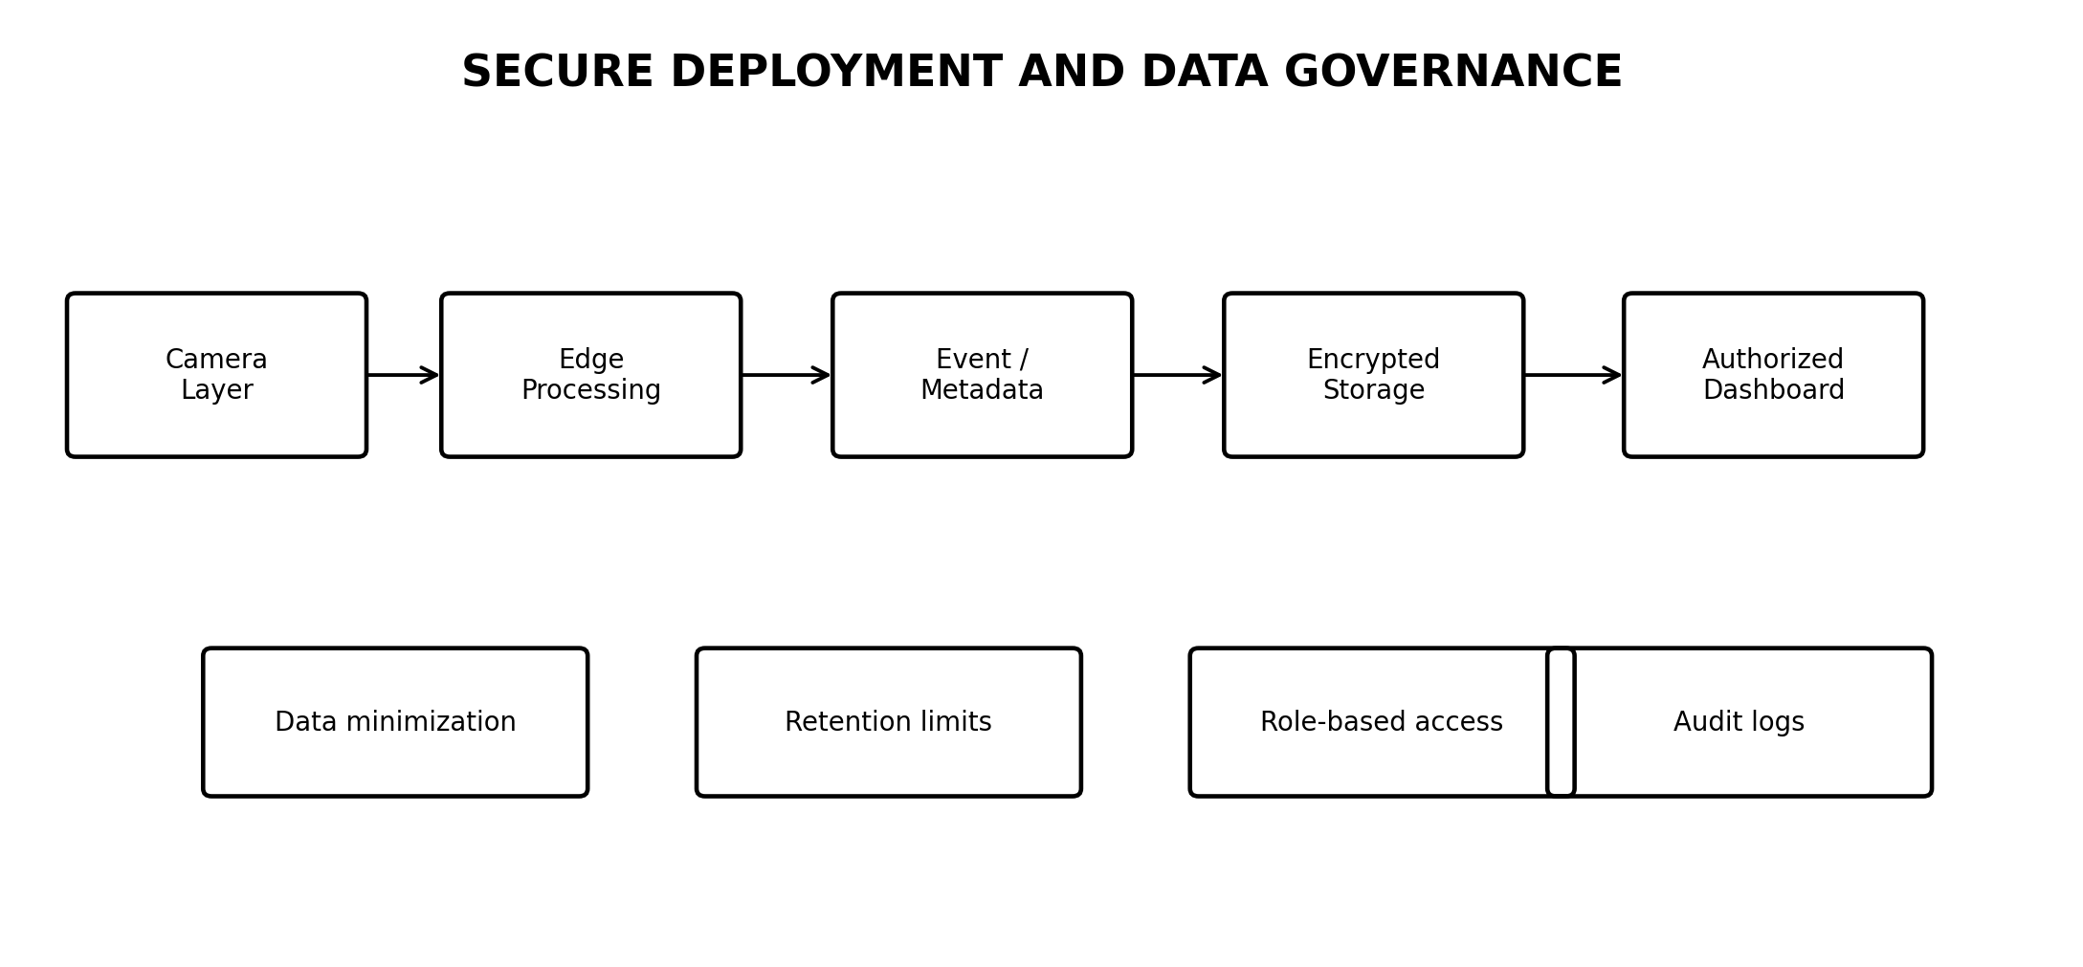

5.1 Privacy and Data Governance
- Use data minimization: collect only information required for the defined security purpose.
- Encrypt sensitive data at rest and in transit.
- Apply role-based access so only authorized personnel can view biometric or vehicle information.
- Define retention and deletion schedules before production deployment.
- Maintain audit logs for sensitive access and administrative changes.
- Prefer edge processing when appropriate to reduce unnecessary transmission of raw video.

5.2 Ethical AI
VisionGuard should be treated as a decision-support system rather than an infallible authority. Recognition thresholds should be validated, uncertain outputs should be escalated, and model performance should be monitored after deployment. The system should not infer intent from appearance alone; surveillance alerts must be based on explicitly defined and reviewable criteria.

5.3 SDG Mapping
- SDG 9 – Industry, Innovation and Infrastructure: applies computer vision and AI to intelligent campus infrastructure.
- SDG 11 – Sustainable Cities and Communities: contributes to safer and more efficiently monitored institutional spaces.
- SDG 16 – Peace, Justice and Strong Institutions: supports controlled access, accountable monitoring and secure institutional operations.
These SDG mappings are directly aligned with the supplied assignment brief. fileciteturn0file0L47-L50
CHAPTER 6

REFLECTION & CONCLUSION

6.1 Learning Outcomes
- Applied image enhancement, filtering, segmentation and feature extraction to practical vision problems.
- Learned to compare handcrafted features with learned representations using engineering criteria.
- Understood why recognition and surveillance require different algorithms.
- Developed an end-to-end architecture instead of treating individual algorithms as isolated exercises.
- Recognized the importance of privacy, human review, validation and deployment constraints.

6.2 Conclusion
VisionGuard demonstrates a practical way to integrate computer vision into campus access and surveillance. The recommended design is hybrid: OpenCV provides the efficient and interpretable image-processing foundation, while deep learning handles the most variation-sensitive recognition and detection tasks. Face recognition benefits from CNN embeddings; plate recognition benefits from learned localization plus OCR; and library monitoring benefits from object detection combined with tracking and temporal reasoning.
The strongest implementation strategy is therefore to benchmark a traditional baseline against the advanced pipeline under the same test conditions. Accuracy alone is insufficient. The final choice should consider false accepts/rejects, false alarms, latency, hardware usage, training data, maintainability and privacy. This directly addresses the assignment’s evaluation requirements and supports a realistic campus deployment.

CHAPTER 7

REFERENCES
- Supplied ITA05 Computer Vision assignment brief: VisionGuard problem statement, course outcomes, assessment rubric and deliverables. fileciteturn0file0L42-L56
- Supplied ITA05 Computer Vision assignment brief: assessment criteria for comparison, solution design, analysis and implementation. fileciteturn0file0L79-L105
- Supplied ITA05 Computer Vision assignment brief: deliverables and learning focus. fileciteturn0file0L142-L147
- OpenCV documentation and educational resources for image processing, feature analysis, object detection, tracking, face recognition and OCR.
- Relevant peer-reviewed literature on face recognition, automatic number plate recognition, object detection, tracking and video anomaly detection should be added to the final submission according to the models actually implemented.

APPENDIX – SUBMISSION CHECKLIST
- Source code with modular OpenCV implementation.
- Dataset description and source/collection method.
- Training/testing procedure for learned models.
- Sample face, plate and surveillance detections.
- Accuracy and error-analysis tables.
- Visualizations and annotated output frames.
- README with installation and execution instructions.
- GitHub repository link submitted with the assignment.
The checklist follows the assignment’s stated implementation, results and GitHub deliverables. fileciteturn0file0L142-L145

